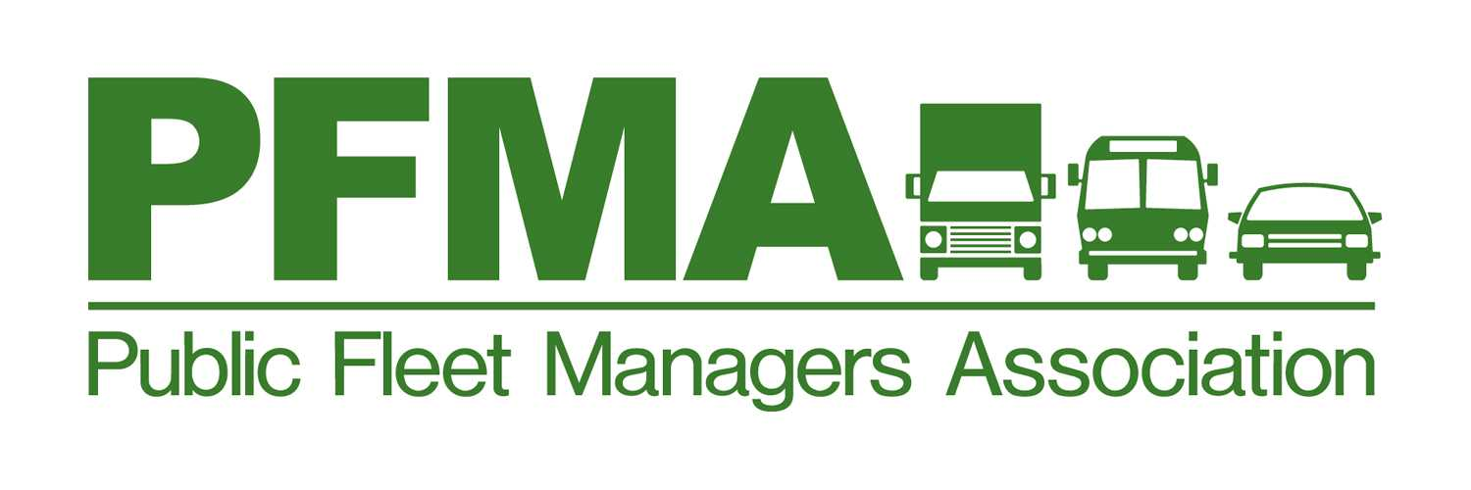

Host: Jason Alvord
Equipment Rental & Revolving Fund Manager
Yakima County Maintenance & Operations Complex
1216 S 18th Street
Yakima, WA 98901
Thursday, October 19, 2017

8:45 am – 9:00 am | Morning Social, snacks and beverages | Sponsored by
9:00 am – 9:30 am | Welcome & Introductions,  Minutes,  Financial report,  Training report,  2017 Work plans and goals,  By-law updates. | Scott Rood, President and PFMA Officers
9:30 am – 10:30 am | PFMA membership,  “Round the Horn”:  Organizational reports, What’s new, Projects, Problems, Etc. | Scott Rood, President and PFMA Officers
10:30 am – 11:30 am | Fleet Operations  Fleetshare- on-line reservation- use vehicle by proximity card  Sheriff Vehicles- Upfitting In-House Advantages/Disadvantages | Jason Alvord  Equipment Rental & Revolving Fund Manager
11: 30 am - 12:00 pm | Remarketing Trends/Best Times of Year to Sell Equipment | Rick Deitrick, GovPlanet
12:00 pm – 12:30pm | Lunch Social | Sponsored by  GovPlanet
12:30 pm – 1:30 pm | Fuel Tank Cleaning/Fuel Testing | Jill Cunningham, Fuel Care
1:30 pm– 2:00pm | Selecting the Right Battery- Solar Chargers/ Battery Technology | Full Throttle Batteries-Pape Batteries
2:00 pm– 2:30pm | Adjourn Meeting | Scott Rood, President
2:30 pm- 3:00pm | Maintenance Facility Tour | Jason Alvord

Next Meeting/Events/Training:

Driving Directions to Yakima County Maintenance & Operations Complex

Merge onto I-90 E
At exit 110, take ramp right for US-97 South / I-82 East toward Yakima
At exit 34, take ramp right for WA-24 East toward Moxee
Turn right onto E Nob Hill Blvd
Turn right onto S 18th St
1216 S 18th St, Yakima, WA 98901

